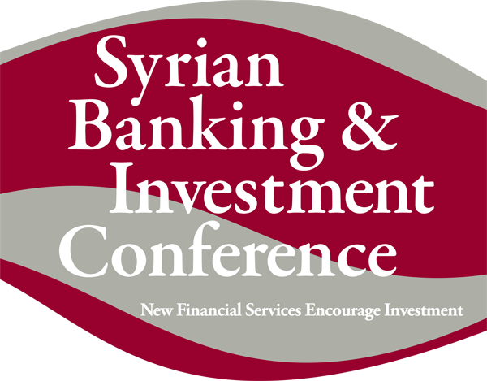
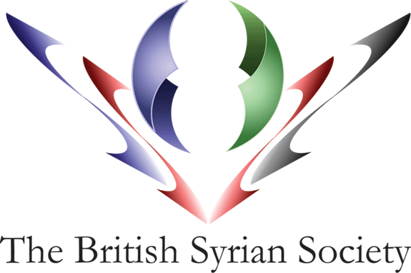

Four Seasons Hotel, Damascus, Syria
31st October - 2nd November 2008

EVALUATION FORM

Thank you for participating in the Syrian Banking & Investment Conference 2008. We value your feedback on how it met your expectations and are interested to hear your suggestions for future events. We would appreciate it therefore if you could complete this form and return it to us by fax or email at the addresses shown below or hand it back to the organisers if you have time. This form will also be uploaded to our conference website http://www.syrianbankingconference.org/

Name:

Organisation:

Email address:

1. Before attending, what did you expect to get out of the conference?

2. Were your expectations:
Exceeded Please comment on how your expectations were or were not met
Fully met
Partly met
Hardly met
Not met at all

3. Overall, how would you rate the quality of the conference?
Excellent Please comment on the overall quality of the conference:
Good
Average
Poor
Very poor

4. How relevant was the conference to you?
Completely relevant Please comment on the relevance of the conference:
Mostly relevant
Somewhat relevant
Not very relevant
Not at all relevant

5. How would you evaluate the speakers?
Excellent Do you have any particular recommendations regarding speakers?
Very Good
Good
Average
Poor

The main objectives of this conference were to address the current development of Syria’s banking and financial sectors, to explore the advantages of Syria as an attractive destination for foreign investors and to deliberate further recommendations to enhance the Syrian economy.

6. To what extent do you agree that this conference met its objective?
Strongly agree Please comment on how the objectives were or were not met:
Tend to agree
Neither agree nor disagree
Tend to disagree
Strongly disagree

7. How did you hear about the event?
Mailing list – please specify
Advertisement – where?
Through a friend
Other – please specify

8. Do you have any other suggestions or comments that might help improve our future events?

PLEASE EMAIL THIS FORM TO:
contact@britishsyriansociety.org britishsyriansociety@btconnect.com
OR FAX TO: +963 11 4411330 or +44 (0) 207 839 1638

THANK YOU

